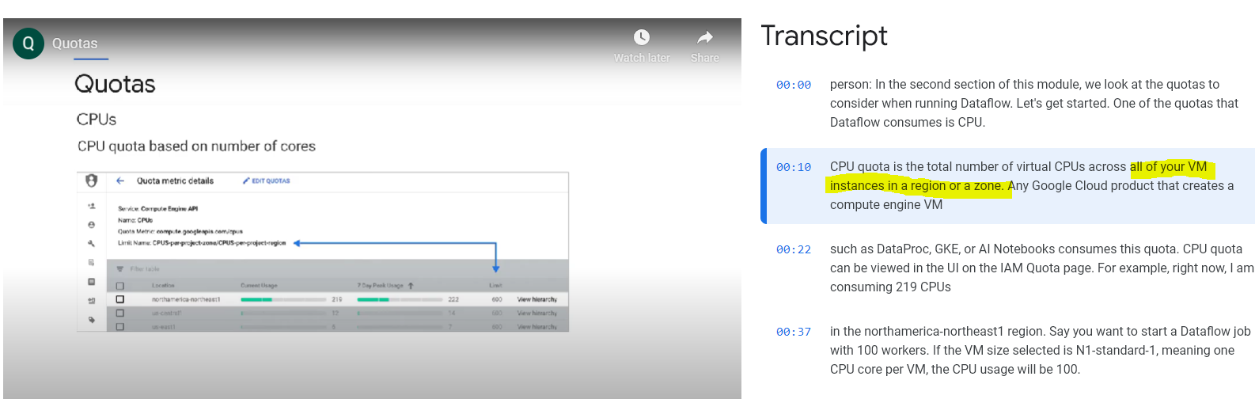

THE CPU QUOTAS LIMITS THE NUMBER OF CPUs ACTIVE AT THE SAME TIME, NOT THE USAGE OF THE CPUs.

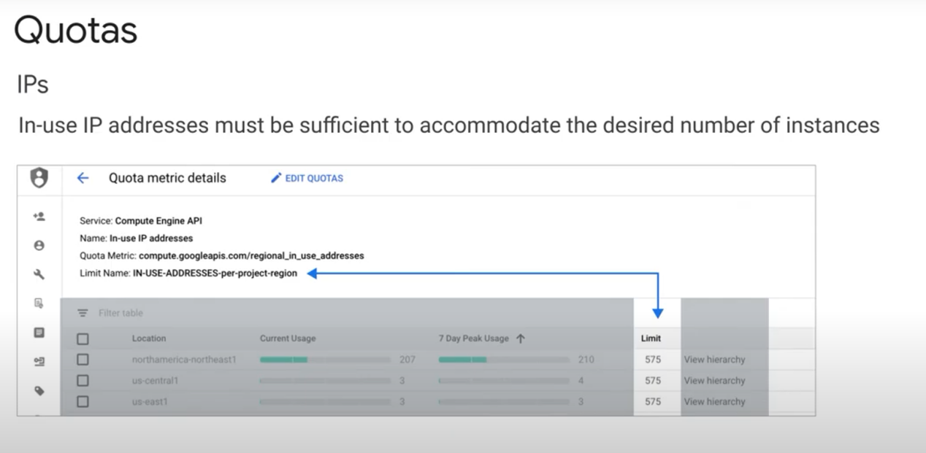

However, if your job does not need to access any external APIs or services, you can launch the Dataflow job using internal IPs only, which saves money and conserves the in-use IP address quota.

If you have multiple quotas (cpu, IP, etc...), When you launch a Dataflow job, **the more restrictive quota takes precedence.**

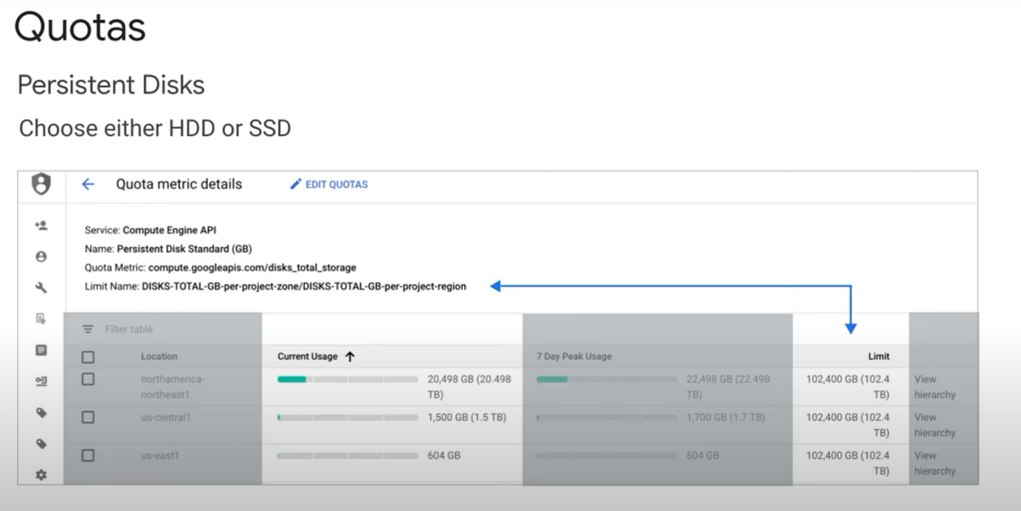

E.g to set the storage unit to SSD:

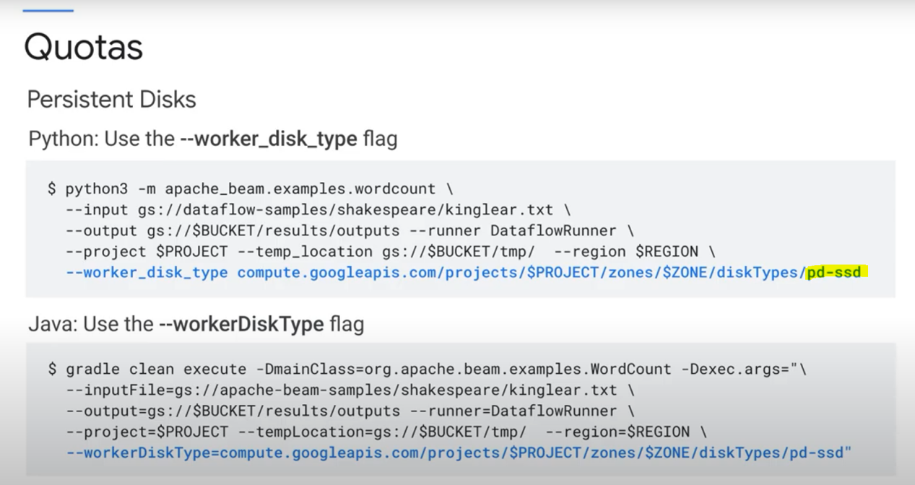

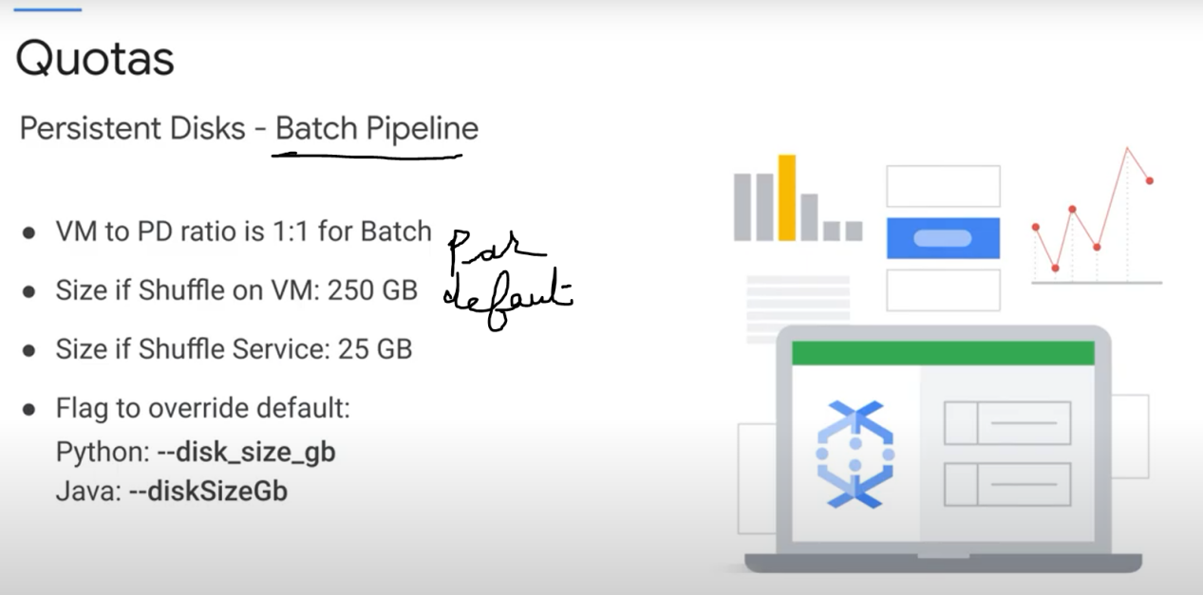

. When you launch a batch pipeline, the ratio of VMs to PDs (persistent disks) is 1:1.

Note: Dataflow Shuffle Service moves the Shuffle operation out of the worker VMs and into the Dataflow service back end, which is why the default persistent disk size

